CHAPTER 15: CGI PROGRAMMING IN PYTHON
TOPICS COVERED:
15.1 WHAT IS CGI?
15.2 HOW CGI PROGRAMMING SUPPORTS WEB BROWSING?
15.3 CONFIGURING CGI IN WAMP SERVER
15.4 MODUES USED IN CGI SCRIPTS
15.5 FIELD STORAGE ATTRIBUTES AND METHODS
15.6 CGI PROGRAM STRUCTURE
15.7 SAMPLE CGI SCRIPTS
15.1 WHAT IS CGI?
- CGI stands for Common gateway interface and this is an essential component of hypertext transfer protocol (HTTP).
- CGI is also known as a standard protocol for web servers to render outputs of console based applications to produce dynamic web pages as the expected result.
- CGI scripts can be of any forms like python script, Perl script, shell script or c, c++ program.
- CGI is a set of standards which defines a way of passing information or request from client side to be passed via http server to corresponding web server to get the requested URL page as an output. This output will be displayed in client’s browser window.
- CGI is also a technique for sending data forth and back between server and client.
- In CGI programming, Once the requested URL reaches web server, it passes the request information to all application program components so that it can process data and returns an acknowledged message.
- In early days of browsing in worldwide web, web servers usually returns static web page contents stored in document root folder of local file system. In order to achieve dynamically generated web contents those days they have used CGI programming.
15.2 HOW CGI PROGRAMMING SUPPORTS WEB BROWSING
- The following procedure describes what happens when a user clicks a hyperlink to browse a particular web-page or URL
  - Browser contacts the HTTP web server for demanding the URL
  - Parsing the URL
  - Look for the filename
  - If it finds that file, a request is sent back
  - Web browser takes a response from the web server
  - As the server response, it either shows the received file or an error message.
  - It may become possible to set-up an HTTP server.
  - When a certain directory is requested, that file is not sent back; instead, it is executed as a program, and that program's output is displayed back to your browser.
15.3 CONFIGURING CGI IN WAMP SERVER
- Open and Run WAMP server from desktop location
- Select httpd.conf file from Apache root of WAMP server.
- Select DocumentRoot directory using shortcut ctrl+f and apply C:\wamp\www.
- Here, create a new AddHandler for cgi scripts to be stored in either .py or .cgi extension.
- Also include ExecCGI to allow execution support for CGI scripts.
- Also check out the availability of multiviews, indexes and system links which are previously defined to support CGI programming.
- After performing these changes save the file and go to apache modules in Apache root folder of WAMP server.
- Confirm Header module is already selected using tick mark.
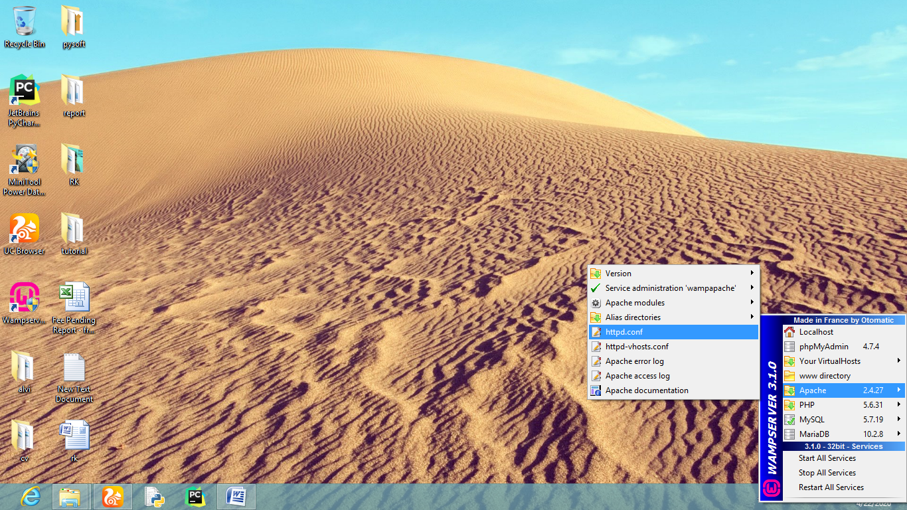
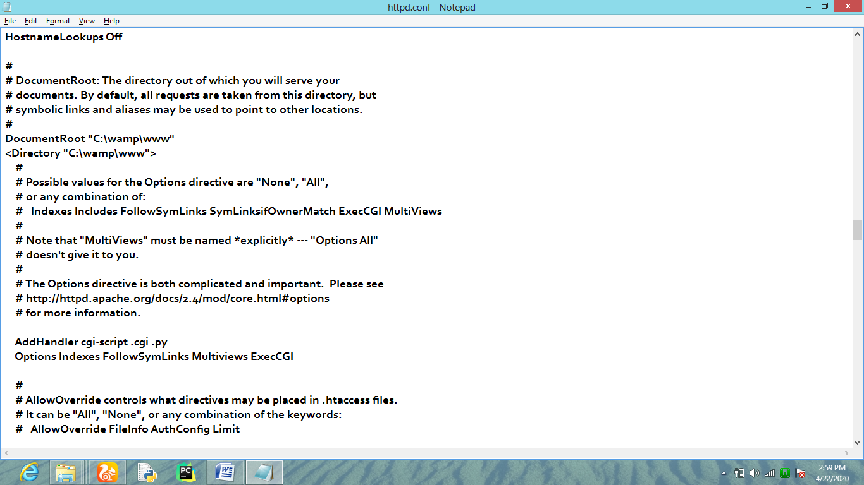
15.4 MODULES USED IN CGI SCRIPTS
- Python's standard library consists of two modules for CGI support. There are,
  - cgi module
  - cgitb module

- The cgi module defines number of utilities to be used by Python CGI script.
- The cgitb module is a traceback manager for CGI scripts which describes trace back information along with error and exception handler information. For this, we need to enable the cgitb module in custom script.
    - >>> import cgi
    - >>> import cgitb
    - >>> cgitb.enable ()
- In cgi programming, usually client browser interacts with the web server using HTTP protocol and HTTP requests are sent to a server URL via either get or post methods.
- GET method sends the data from client in an unencrypted form, hence it is considered to be unsafe.
- POST method is normally used to send data in HTML form of the client. The HTTP header contains encrypted data of form.
  - [NOTE: cgi module defines a FieldStorage class. The data received from client request is collected in FieldStorage object.
  - This is similar to Python's dictionary object consisting of form elements and their respective values.
  - Once the form data is retrieved by FieldStorage object on server side, the Python script can perform required process and render HTML output back to the client browser. ]
15.5 FILED STORAGE ATTRIBUTES AND METHODS

FieldStorage attributes:
Name | The field name
Filename | Client side filename.
Value | The value as a string. For file uploads, reads the file and returns bytes
File | The file(-like) object from which you can read the data as bytes
Type | The content-type
Headers | A dictionary(-like) object containing all headers
FieldStorage methods:
getfirst() | Return the first value received.
getlist() | Return list of received values.
getvalue() | Dictionary style get() method.
keys() | Dictionary style keys() method.
make_file() | Return a readable & writable file.

15.6 CGI PROGRAM STRUCTURE
#!C:\Python36\python.exe →(shebang line to intimate web server
About type of executable take care
Of remaining script execution)

print ("Content-type: text/html\r\n\r\n") →(to render output)
print ("<html>")
print ("<head>")
print ("<title>CGI PROGRAMMING </title>")
print ("<head>")
print ("<body>")
print ("<h3>WHAT TO DESCRIBE IN THIS PART </h3>")
print ("</body>")
print ("</html>")
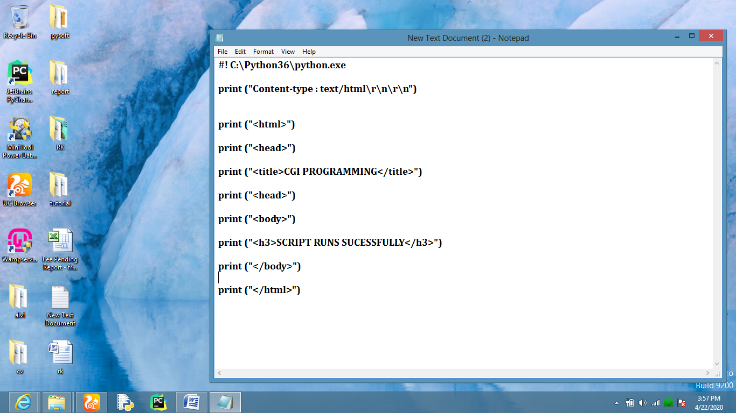
15.7 SAMPLE CGI CODES
